1. **Research and Review Website:**

* **Sendflowers.com:**



Likes:

1. Have options of occasions to purchase the flowers accordingly.

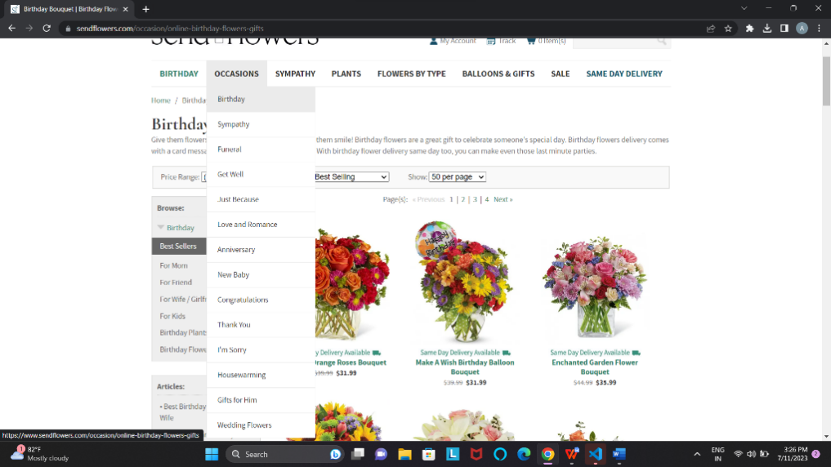

1. Can adjust the price range of the flowers.

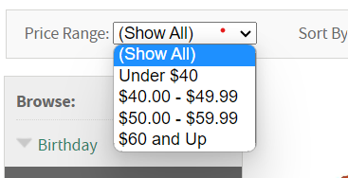

1. Have option to share email to get fantastic offers for special occasions and daily discounts.

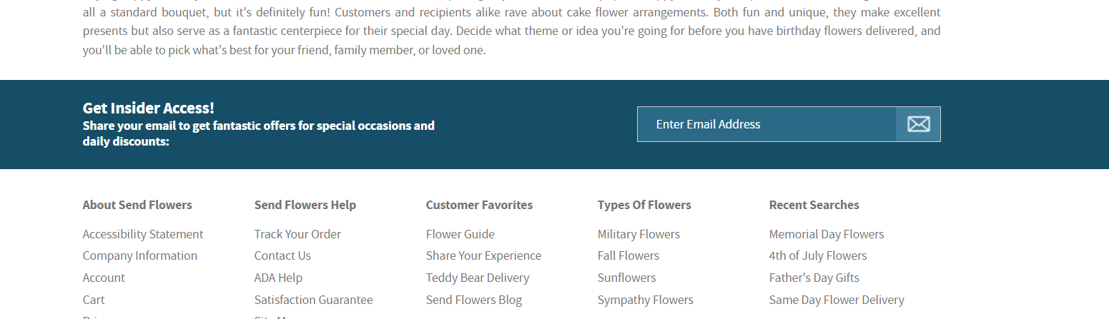

1. Can decide the number of flowers you want to see on one webpage.

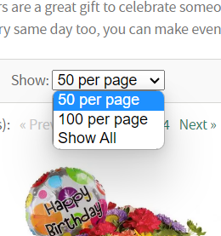

Dislikes:

1. Color theme is not attractive.
2. Aligmnent of the elements is confusing.

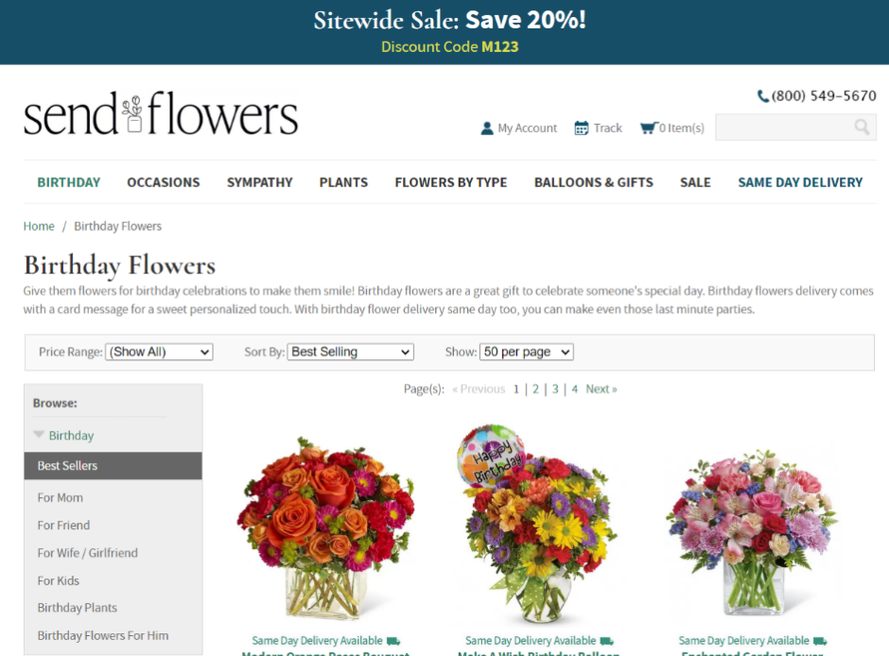

3.There is no contact us page.

4.No sales page.

* **Phoolwala.com**

Phoolwala.com is an Indian online flower delivery website that was founded in 1999. They are one of the leading online florists in India and offer a wide variety of flowers, cakes, and gifts for all occasions. Phoolwala.com delivers flowers to over 500 cities in India and internationally

 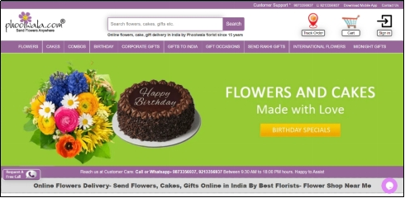

Likes:

1. Extensive dropdown. Users can personalize their flower arrangements according to the event they are being delivered.

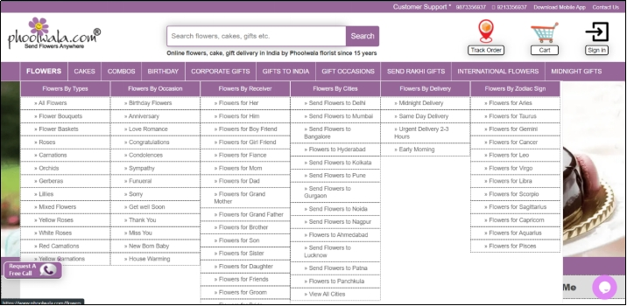

1. Wide range of filters available.

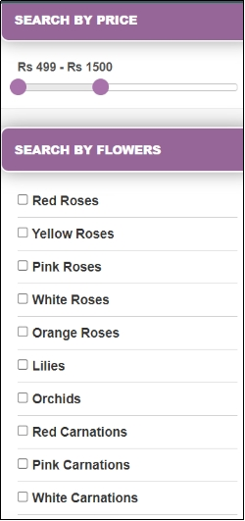

1. Easy to use: Navigation is clear, the search function is user-friendly, and the overall interface is intuitive.
2. Frequently Asked Questions are provided (FAQs)

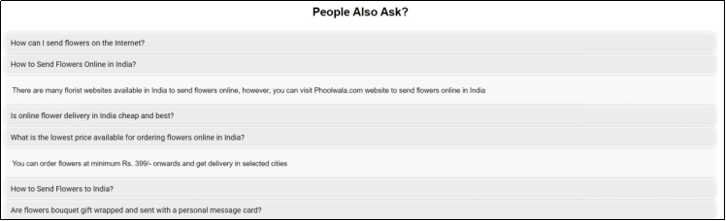

1. Easy back to the previous page navigation provided at each page.



Dislikes:

1. The website's navigation can be a bit confusing. For example, the "About Us" page is not linked from the main menu, and the "Contact Us" page is only accessible from the footer.
2. The website's design is a bit dated. The website could benefit from a more modern design that is more responsive and user-friendly.
3. The website displays identical customer reviews and fraudulent reviews for all products, indicating poor web development and a lack of up-to-date information.

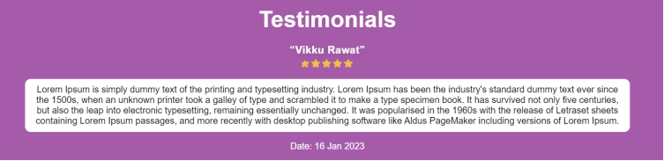

1. Some parts are not responsive. E.g., The navigation bar disappears after the screen size reduces.
2. The website's images are not always optimized for the web. This can make the website load slowly, especially on mobile devices.

Link: <https://www.phoolwala.com/>

* **Flowerapp.com**

Flower app, operating through its website www.flowerapp.com, is a premier online flower delivery service. Offering a wide range of fresh and exquisite flowers, they provide a seamless and convenient experience for customers. With meticulous attention to quality, their handcrafted bouquets cater to diverse tastes and occasions. From vibrant roses to rare orchids, flowerapp ensures each stem is delivered at peak freshness, creating a memorable sensory experience. With easy customization options and efficient delivery, they are the go-to destination for exceptional floral gifts.

Website’s Look (front end)

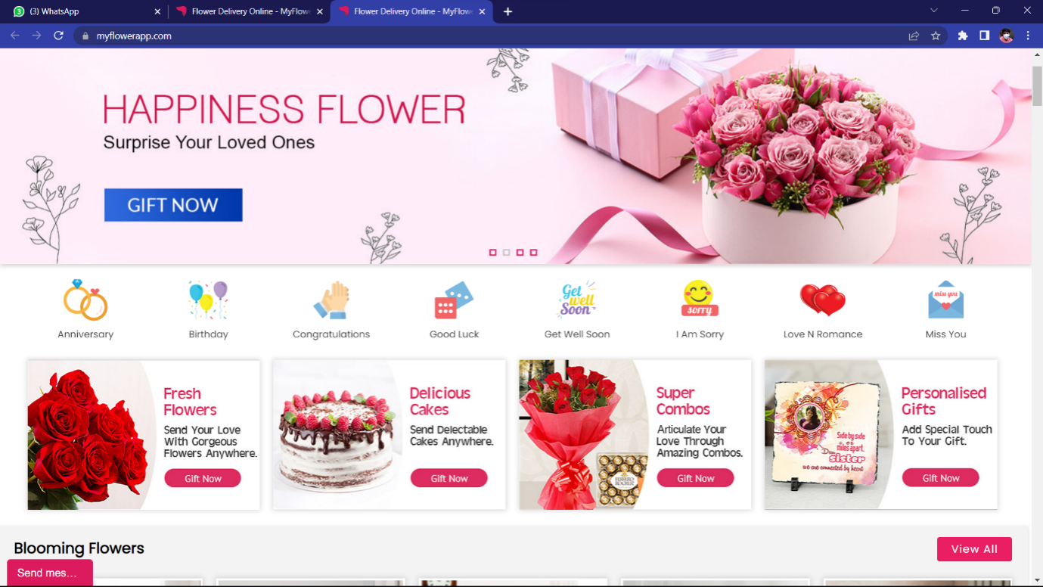

Good Features:

1. Simple and clear pages.
2. No Advertisement secessions.
3. Has customer review secession.

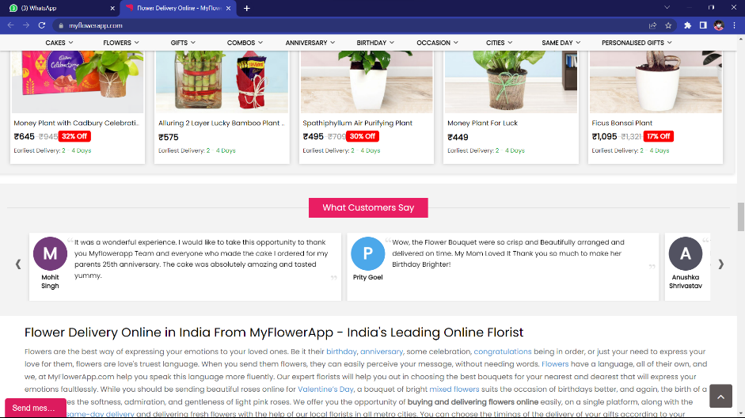

4)Simple but effective footer.

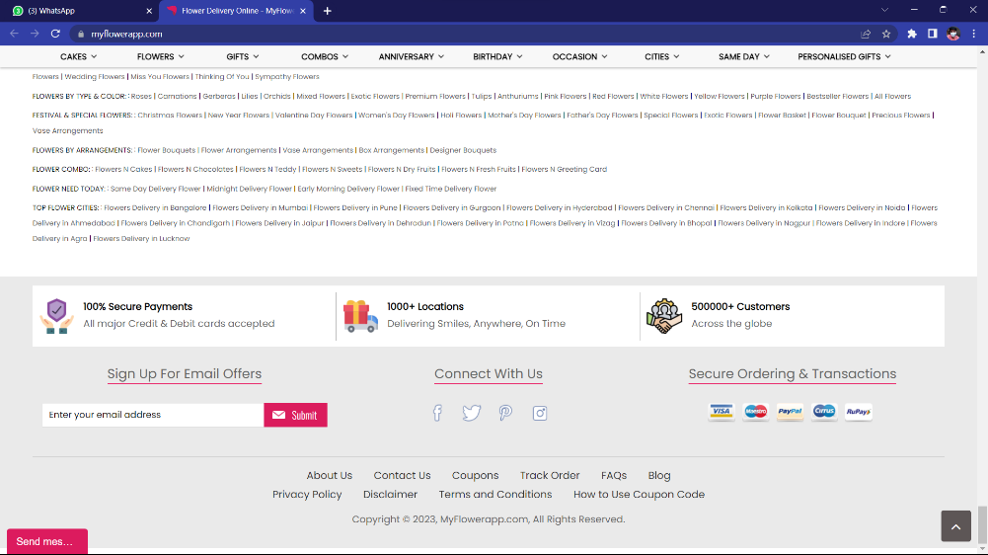

1. Use of Vector images.
2. 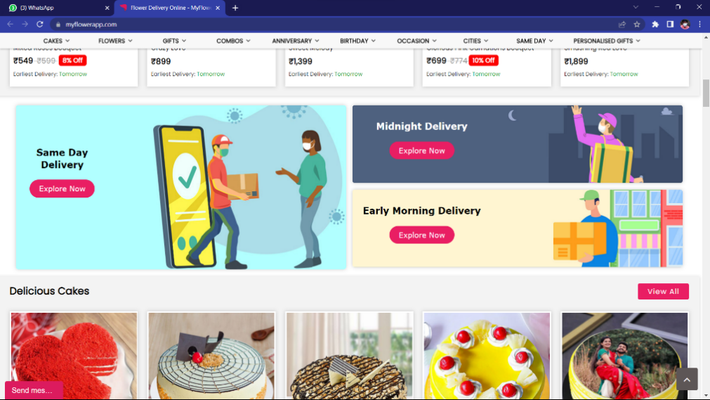

Things that I don’t Like:

1. Visible scroll bar

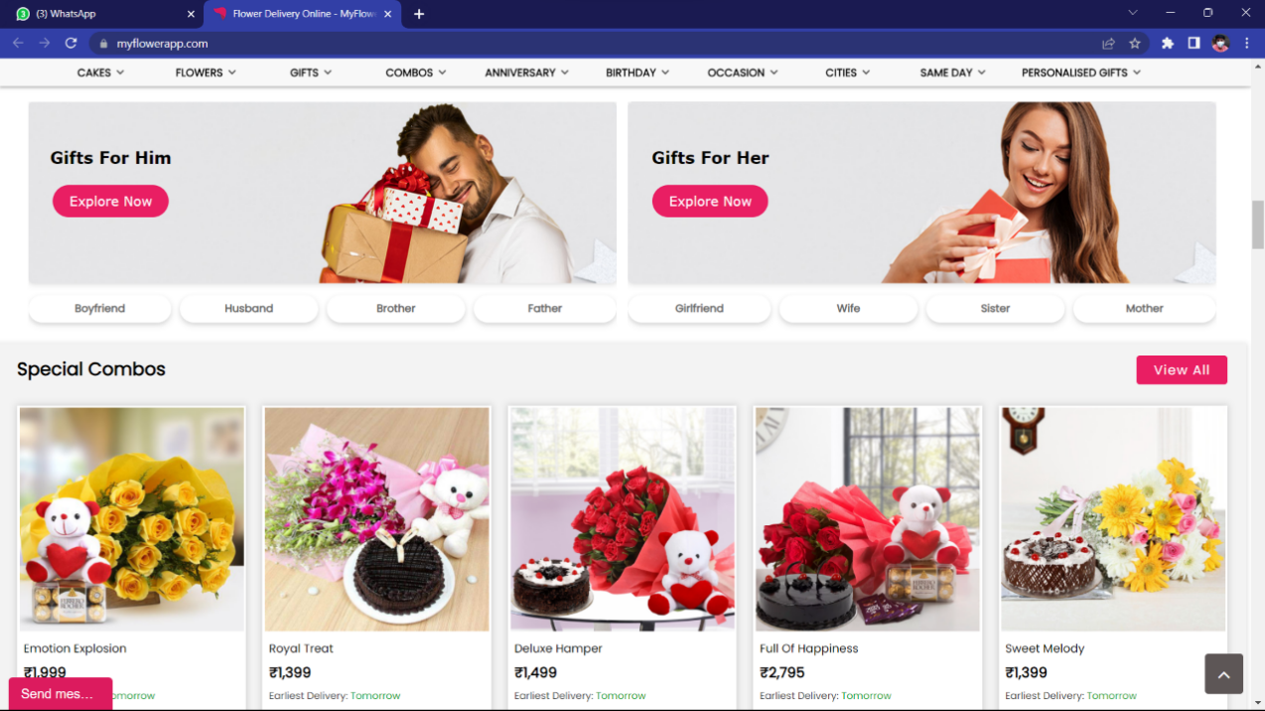

1. Documentation is boring.

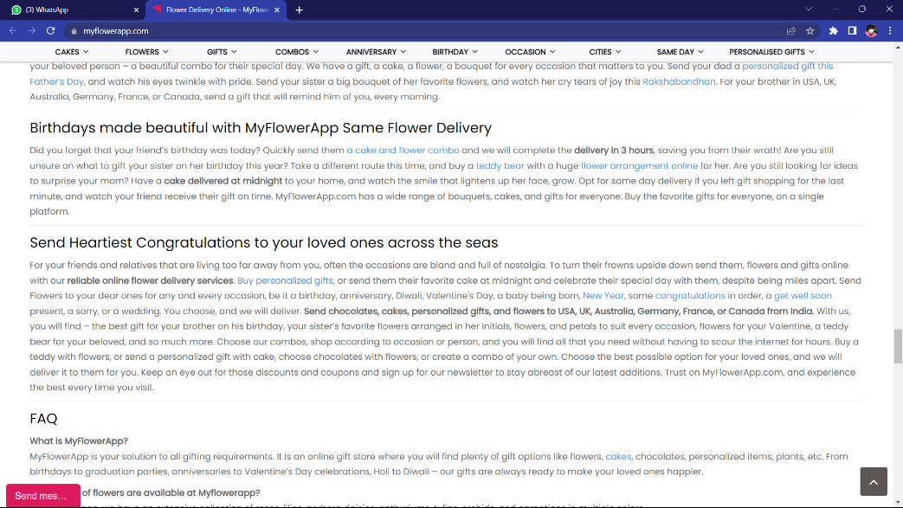

1. Too much options.

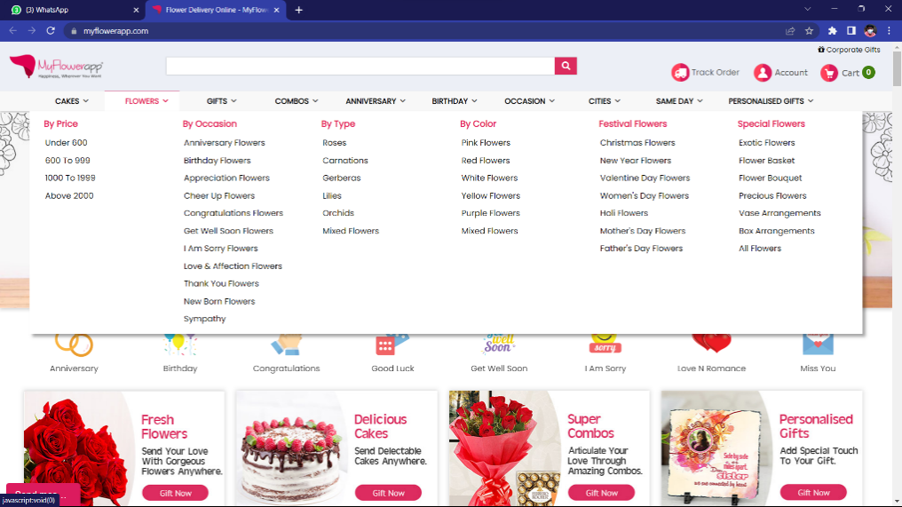

4)Not well categorised.

5) Sign up process is not much cool.

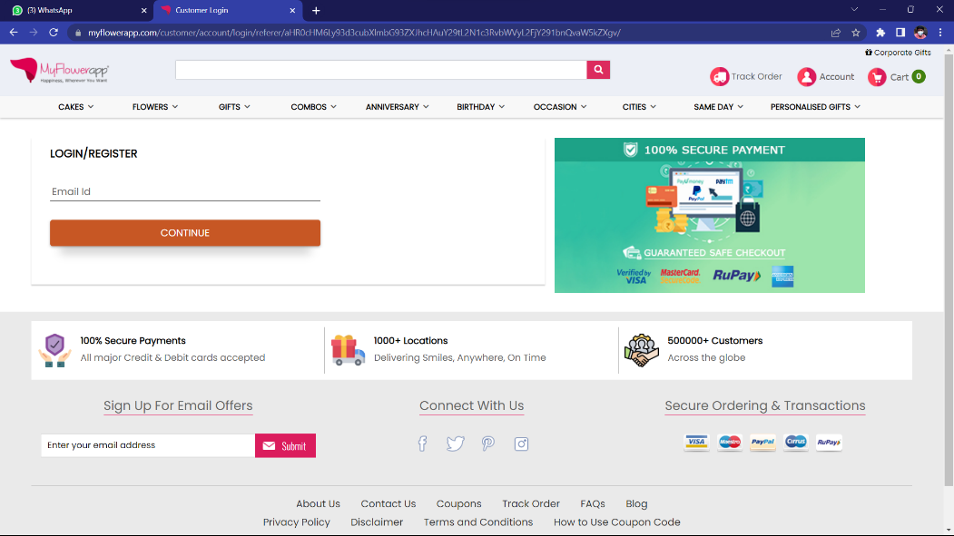

1. *Mission Statement*

**“To provide our customers with the highest quality flowers and floral arrangements, delivered with care and attention to detail.”**

This mission statement is more detailed than the one-line statement I provided earlier. It includes the following elements:

* Quality: We are committed to providing our customers with the highest quality flowers and floral arrangements. We source our flowers from reputable growers and ensure that they are fresh and beautiful.
* Care: We take care in the delivery of our flowers. We ensure that they are properly packaged and shipped so that they arrive in perfect condition.
* Attention to detail: We pay attention to detail in all aspects of our business. We want our customers to have a positive experience from start to finish.

1. *List of Criteria*

Criteria to Take in consideration while making websites:

1. Secure and Safe:

Implement security measures such as SSL certificates, encryption, and protection against vulnerabilities to ensure the safety of user data.

1. Fast Page Loading:

Optimize the website for fast loading times to provide a smooth and efficient user experience.

1. Clear Call-to-Action:

Use prominent and compelling call-to-action buttons or links to guide users towards desired actions such as making a purchase or signing up for a newsletter.

1. Social Media Integration:

Incorporate social media buttons or widgets to allow users to easily share content and connect with your brand on social platforms.

1. Mobile Optimization:

Ensure the website is fully optimized for mobile devices, with responsive design, mobile-friendly navigation, and touch-friendly elements.

1. Analytics and Tracking:

Implement analytics tools such as Google Analytics to gather data on user behavior, website performance, and conversion rates. This data can help inform future improvements and marketing strategies.

1. Error Handling:

Provide clear error messages and user-friendly forms that help users easily correct mistakes or input errors.

1. Scalability:

Design the website with scalability in mind, allowing for future growth and expansion without major architectural changes.

1. Browser Consistency:

Test the website across different browsers and browser versions to ensure consistent functionality and appearance for all users.

1. Accessibility Compliance:

Follow accessibility guidelines such as WCAG (Web Content Accessibility Guidelines) to make the website accessible to users with disabilities, including proper use of alt text, keyboard navigation, and screen reader compatibility.

1. *Measurement of Success*

The following measurements of success reflect the impact and effectiveness of the website in driving business growth and achieving strategic goals.

1. Increasing customer satisfaction and loyalty:

Our website has achieved a customer satisfaction rating of 90%, resulting in a 30% increase in customer loyalty and repeat purchases.

2. Growing website traffic and reach:

We have successfully increased website traffic by 50%, reaching a wider audience and expanding our brand's online visibility.

3. Boosting average order value:

Through strategic upselling and cross-selling techniques on our website, we have seen a 25% increase in the average order value, maximizing revenue per customer.

4. Enhancing lead generation and conversion:

Our optimized landing pages and lead capture forms have led to a 40% increase in lead generation, with a conversion rate of 20% resulting in new customer acquisitions.

5. Decreasing bounce rate and improving engagement:

By implementing user-friendly navigation and engaging content, we have reduced the website's bounce rate by 15% and increased average session duration by 20%, indicating higher user engagement.

1. *Visual Style of Website*

Basic layout of homepage:

Flow:

Homepage

* Hero section

* Featured products

* Call to action

About Us

* About us content

* Testimonials

* Call to action

Contact Us

* Contact form

* Social media links

* Call to action

Products

* Product filters

* Product grid

* Product details

* Add to cart button

Cart

* Cart contents

* Shipping information

* Payment information

* Place order button

Checkout + Payment + Place Order

* Order summary

* Review order

* Place order button

Past Orders

* Past order list

* Order details

Header

* Logo

* Tagline

* Main navigation

Footer

* Contact information

* Social media links

* Copyright information

The header and footer are consistent across all pages, and the main navigation is prominently displayed on each page. The products page features a large, high-quality image of flowers, and the cart page shows a list of the flowers that have been added to the cart. The checkout + payment + place order page shows a summary of the order, and the past orders page shows a list of the customer's past orders.

Additional visual styles:

* 1. Color Palette:

The website employs a soothing and maroon color palette. This color scheme evokes a sense of calmness, serenity, and trust, aligning with the brand's message of reliability and tranquillity.



* 1. Typography:

The headings use a modern and clean font that looks contemporary and friendly. The body text uses a clear and easy-to-read font. The font sizes are well-balanced, with slightly larger headings to make important information stand out.

* 1. Responsive Design:

The design adapts well to different devices and screen sizes.